>
slabye i sil'nye razryvy rewenii nelineynyh yravnenii.
Shabaeva Alisa MKM.
> restart:
> with(plots):
vvod ishodnyh dannyh:
F(u)=cosu, U0(x)=x;

> F := u->cos(u);
> U0 :=x->x;
rewenie yravneniya u-U0(x-F'(u)*t)=0 pri t=0;
> implicitplot(u-U0(x)=0,x=-1..1,u=-1..1);

rewenie yravneniya u-U0(x-F'(u)*t)=0 pri t=0.5
> implicitplot(u-U0(x+sin(u)*0.5)=0,x=-1..1,u=-1..1);

>
> G:=implicitplot((u-U0(x)=0,x=-1..1,u=-1..1),style=line, color=blue):
L:=implicitplot((u-U0(x+sin(u)*0.5)=0,x=-1..1,u=-1..1),style=point): display({G,L},axes=boxed,scaling=constrained,title=`yravnenie`);

>
> G:=implicitplot((u-U0(x)=0,x=-1..1,u=-1..1),style=line, color=blue):
L:=implicitplot((u-U0(x+sin(u)*0.5)=0,x=-1..1,u=-1..1),style=point):
> H:=implicitplot((u-U0(x+sin(u)*0.1)=0,x=-1..1,u=-1..1),style=point,color=yellow):
> J:=implicitplot((u-U0(x+sin(u)*0.2)=0,x=-1..1,u=-1..1),style=line,color=black):
> M:=implicitplot((u-U0(x+sin(u)*0.3)=0,x=-1..1,u=-1..1),style=point,color=pink):
> C:=implicitplot((u-U0(x+sin(u)*0.4)=0,x=-1..1,u=-1..1),style=point,color=green):
> N:=implicitplot((u-U0(x+sin(u)*0.6)=0,x=-1..1,u=-1..1),style=point,color=orange):
> B:=implicitplot((u-U0(x+sin(u)*0.1)=0,x=-1..1,u=-1..1),style=point,color=brown):
> T:=implicitplot((u-U0(x+sin(u)*0.1)=0,x=-1..1,u=-1..1),style=point,color=blue):
> P:=implicitplot((u-U0(x+sin(u)*0.7)=0,x=-1..1,u=-1..1),style=point):
> Q:=implicitplot((u-U0(x+sin(u)*0.8)=0,x=-1..1,u=-1..1),style=point,color=yellow):
> R:=implicitplot((u-U0(x+sin(u)*0.9)=0,x=-1..1,u=-1..1),style=point,color=green):
> K:=implicitplot((u-U0(x+sin(u)*1)=0,x=-1..1,u=-1..1),style=point,color=black):
> display({G,H,J,M,C,L,N,B,T,P,Q,R,K},axes=boxed,scaling=constrained,title=`yravnenie`);

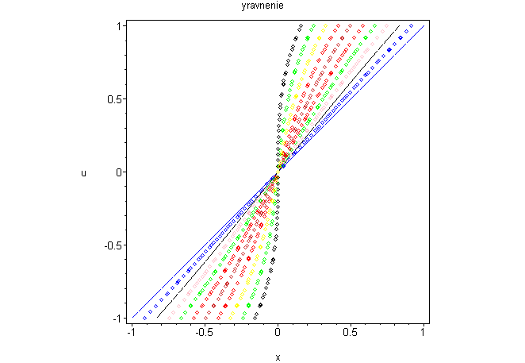
> B1:=(x,t)->solve (u-U0(x+sin(u)*t)=0,u);
> B1(5,2);
> evalf(%);
> animate([B1(x,t),x,x=-1..1],t=0..1,frames=10);
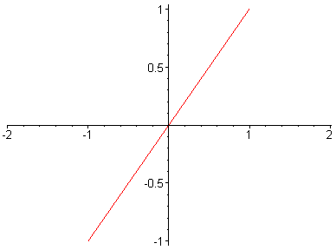
> ? animate
>
>

